|  |
| --- |
| AIC, MATHEMATICS LEARNING AREA  **YEAR 12 MATHEMATICS APPLICATIONS – UNIT 3**  **Assessment Type: Response - 6%**  **TASK 3 - TEST 2 –** **Term 1, Week 4**  **SECTION 1: CALCULATOR-FREE**  **Syllabus Content:** 3.2.1 – 3.2.11  Arithmetic sequences, Geometric Sequences, First-order linear recurrence relations |

Student Name: __________________________________________

ID: _______ Date: _______

**TIME ALLOWED: 15 minutes** under test conditions

**Section 1: 15 minutes**

**Section 2: 35 minutes**

**MATERIAL REQUIRED / RECOMMENDED FOR THIS PAPER:**

*TO BE PROVIDED BY THE SUPERVISOR*

Question/answer booklet.

*TO BE PROVIDED BY THE CANDIDATE*

*Standard Items:* pens, pencils, pencil sharpener, highlighter, eraser, ruler.

**IMPORTANT NOTE TO CANDIDATES**

No other items may be taken into the examination room. It is **your** responsibility to ensure that you do not have any unauthorised notes or other items of a non-personal nature in the examination room. If you have any unauthorised material with you, hand it to the supervisor **before** reading any further.

**Structure of this paper**

|  |  |  |  |  |
| --- | --- | --- | --- | --- |
| Section | Number of questions available | Number of questions to be attempted | Suggested working time (minutes) | Marks available |
| **Calculator Free** | **2** | **2** | **15 minutes** | **15** |
| **Calculator Assumed** | **4** | **4** | **35 minutes** | **35** |
|  | | | **Marks available:** | **/50** |
| **Task Weighting** | 6% |

**Instructions to candidates**

* The rules for the conduct of this examination are detailed in the booklet *WACE* *Examinations*

*Handbook*. Sitting this examination implies that you agree to abide by these rules.

* Answer the questions in the spaces provided.
* Spare answer pages can be used. If you need to use them, indicate in the original answer space where the answer is continued.

Question 1 (6 marks)

A sequence is defined by $T_{n+1}=T_{n}-8, T_{1}=55$.

(a) Write the first six terms of the sequence in the following table. (2 marks)

|  |
| --- |
| **Solution** |
| See table |
| **Specific behaviours** |
| ✓ at least $3$ correct terms  ✓ all correct |

|  |  |  |  |  |  |  |
| --- | --- | --- | --- | --- | --- | --- |
|  |  |  |  |  |  |  |
|  |  |  |  |  |  |  |

(b) Graph the first six terms of the sequence on the axes below. (2 marks)

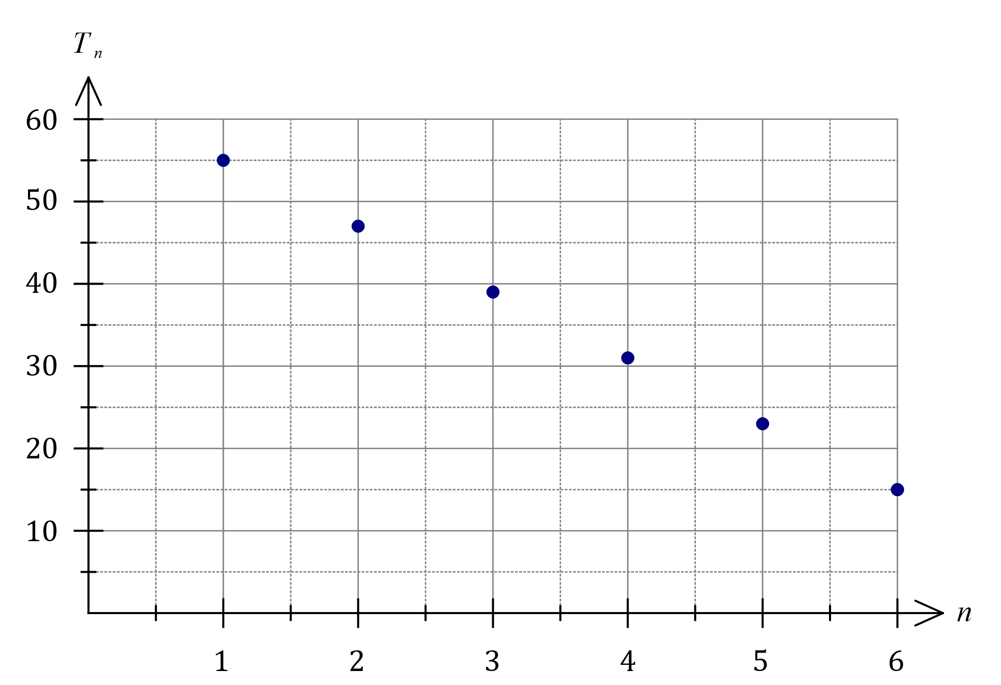

|  |
| --- |
| **Solution** |
| See graph |
| **Specific behaviours** |
| ✓ and $T_{6}$ ✓ all points plotted, no line |

(c) The rule for the $n^{th}$ term of the sequence is $T_{n}=an+b$. Determine the value of the constant $a$ and the value of the constant $b$. (2 marks)

|  |
| --- |
| **Solution** |
| $$T_{n}=55+\left(n-1\right)\left(-8\right) \\ =-8n+63$$ Hence $a=-8$ and $b=63$. |
| **Specific behaviours** |
| ✓ correctly substitutes into $n^{th}$ term rule  ✓ simplifies to show value of each constant |

**Question 2 (9 marks)**

(a) Determine the next three terms for the recurrence relations below.

(i) 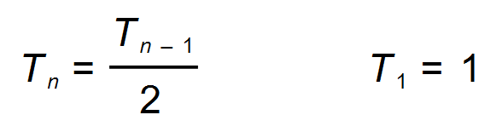 (3 marks)

***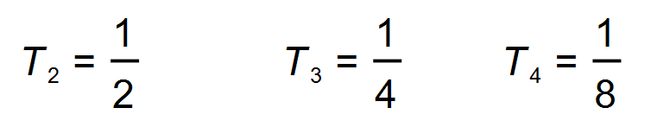* ✓✓✓**

(ii) 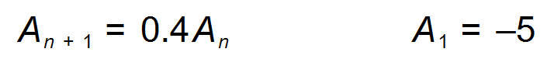 (3 marks)

**✓✓✓**

(b) Give a reason why the value of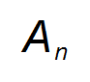in (a) (ii) will never be greater than zero. (1 mark)

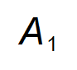**is negative (therefore less than 0) and 0 < *r* < 1 ✓✓**

(c) Some terms of an arithmetic sequence are given below. Write the simplified rule for the *n*thterm for the table of values shown below. (2 marks)

|  |  |  |  |  |
| --- | --- | --- | --- | --- |
| **(term number)** | 3 | 5 | 6 | 10 |
| **(Value)** | 7 | 2 | –0.5 | –10.5 |

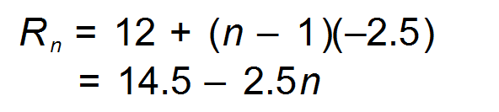 ✓✓

|  |
| --- |
| AIC, MATHEMATICS LEARNING AREA  **YEAR 12 MATHEMATICS APPLICATIONS – UNIT 3**  **Assessment Type: Response - 6%**  **TASK 3 - TEST 2 –** **Term 1, Week 4**  **SECTION 2: CALCULATOR-ALLOWED**  **Syllabus Content:** 3.2.1 – 3.2.11  Arithmetic sequences, Geometric Sequences, First-order linear recurrence relations |

Student Name: __________________________________________

ID: _______ Date: _______

**TIME ALLOWED: 35 minutes** under test conditions

**Section 1: 15 minutes**

**Section 2: 35 minutes**

**MATERIAL REQUIRED / RECOMMENDED FOR THIS PAPER:**

*TO BE PROVIDED BY THE SUPERVISOR*

Question/answer booklet.

*TO BE PROVIDED BY THE CANDIDATE*

*Standard Items:* pens, pencils, pencil sharpener, highlighter, eraser, ruler. Classpad, scientific calculator

**IMPORTANT NOTE TO CANDIDATES**

No other items may be taken into the examination room. It is **your** responsibility to ensure that you do not have any unauthorised notes or other items of a non-personal nature in the examination room. If you have any unauthorised material with you, hand it to the supervisor **before** reading any further.

**Q3 [7 marks]**

For each birthday Isabel receives a sum of money from her grandmother.

On her 15th birthday she receives $50.

On her 16th birthday she receives $55.

Isabel wishes to predict how much she will receive from her grandmother in the future. She thinks the amount she receives could be an arithmetic or geometric sequence.

(a) Complete the two tables below for how much Isabel will receive on her 17th and 18th birthday. (3 marks)

|  |  |  |  |  |  |
| --- | --- | --- | --- | --- | --- |
| **Arithmetic Sequence** | | | | | |
| **Birthday** | 15th | | 16th | 17th | 18th |
| **Amount received** | $50 | | $55 | **$60** | **$65** |
|  |  | |  |  |  |
| **Geometric Sequence** | | | | | |
| **Birthday** | 15th | 16th | | 17th | 18th |
| **Amount received**  **(to the nearest dollar)** | $50 | $55 | | **$60/$61** | **$67** |

|  |  |
| --- | --- |
| **Specific behaviours** | **Point** |
| * Completes arithmetic sequence. * Completes geometric sequence. * Amounts given to nearest dollar. | 3.2.2  3.2.6 |

(b) Complete the recursive rules below, for each of the above tables, where  is the amount Isabel receives on her  birthday. (2 marks)

|  |  |  |  |  |  |  |  |
| --- | --- | --- | --- | --- | --- | --- | --- |
| **Arithmetic Sequence** | | |  | **Geometric Sequence** | | | |
|  | **5** |  |  |  | **1.1** |  |  |

|  |
| --- |
| **Specific behaviours** |
| * Writes in 5. * Writes in 1.1. |

The maximum amount Isabel’s grandmother gives as a birthday present is $80.

(c) Determine on which birthday Isabel will receive $80 from her grandmother.  
Clearly identify your answer for each sequence. (2 marks)

|  |  |
| --- | --- |
| **Solution** | **Specific behaviours** |
| Arithmetic: 21st birthday  Geometric: 20th birthday | * Determines answer for arithmetic sequence. * Determines answer for geometric sequence.   (Penalise one mark if 22nd and 21st) |

Question 4 (7 marks)

An unmanned submarine has to return directly to its host ship, currently at anchor and $315$ km away from the submarine. With failing batteries, the submarine can travel $42$ km in the first hour, $39$ km in the second hour and so on, always $3$ km less than in the previous hour until it no longer moves.

(a) Determine the total distance travelled by the submarine in the first three hours. (2 marks)

|  |
| --- |
| **Solution** |
| $$D_{3}=36$$ Distance $=42+39+36=117$ km. |
| **Specific behaviours** |
| ✓ indicates distance travelled in third hour  ✓ calculates sum of first three terms |

(b) Determine a simplified rule for the distance $D_{n}$ travelled by the submarine in the $n^{th}$ hour. (2 marks)

|  |
| --- |
| **Solution** |
| $$D_{n}=42+\left(n-1\right)\left(-3\right) \\ =45-3n$$ |
| **Specific behaviours** |
| ✓ substitutes $a$ and $d$ into $n^{th}$ term rule  ✓ simplifies and uses $D_{n}$ |

(c) At the start of which hour will the submarine no longer move? (1 mark)

|  |
| --- |
| **Solution** |
| Start of the ${15}^{th}$ hour. |
| **Specific behaviours** |
| ✓ states correct hour |

(d) State, with reasons, whether the submarine will reach its host ship. (2 marks)

|  |
| --- |
| **Solution** |
| $$42+39+36+…+3=315 \text{km}$$ Submarine will just reach its host ship as the total distance it will travel before it stops is $315$ km. |
| **Specific behaviours** |
| ✓ sums distance travelled  ✓ states yes, with reasoning |

**Question 5 (7 marks)**

The seats in an amphitheatre are numbered in numerical order from the first row to the last row, and from left to right as shown in the diagram below.

**<EFOFEX>

id:fxd{9eb9eb3e-397d-43a0-ad5f-6a69ee565aef}


FXData:

</EFOFEX>**

The first row has  seats. Each succeeding row has  more seats than the previous one.

(a) Write down a recursive rule for , the number of seats in row . (2 marks)

|  |  |
| --- | --- |
| **Solution** | **Specific behaviours** |
|  | * Determines recursive rule. * Includes first term. |

(b) The last row in the amphitheatre has  seats. Determine how many rows of seats are in the amphitheatre. (1 mark)

|  |  |
| --- | --- |
| **Solution** | **Specific behaviours** |
|  | * Determines the number of rows. |

(c) A family of four has been allocated seats 119 to 122. Determine if they are sitting in the same row, justifying your answer. (2 marks)

|  |  |
| --- | --- |
| **Solution** | **Specific behaviours** |
| No. The last seat in row 6 is numbered 120. Hence they will not be sitting in the same row. | * Determines the total number of seats in the first six rows. * Concludes the family is not sitting together. |

Due to social distancing requirements, the number of seats in each row is reduced. A new recursive rule for the number of seats in row  is



(d) Describe two changes that have occurred to the arrangement of the seats in the amphitheatre. (2 marks)

|  |  |
| --- | --- |
| **Solution** | **Specific behaviours** |
| The first row now has 8 seats.  Each row has 3 more seats than the previous row. | * States change in first row. * States change in the number of seats added each row. |

**Question 6 (8 marks)**

Saltwater flows steadily into a tank, where it is mixed with existing water. An overflow spout on the tank allows excess water to flow out. The salt concentration in the tank can be modelled by $S_{n+1}=0.95S_{n}+950, S_{0}=1000$, where $S_{n}$ is the concentration, in parts per million, after saltwater has been flowing into the tank for $n$ minutes.

(a) Determine $S_{5}$. (1 mark)

|  |
| --- |
| Solution |
| $$S_{5}=5072 \text{ppm}$$ |
| Specific behaviours |
| ✓ correct value |

(b) Determine the value of $n$ for $S_{n}$ to first exceed $10 000$ ppm. (1 mark)

|  |
| --- |
| Solution |
| $$n=14$$ |
| Specific behaviours |
| ✓ correct value |

(c) Plot points to show the salt concentration at $10$ minute intervals on the axes below, after first adding an appropriate scale to the vertical axis. (3 marks)

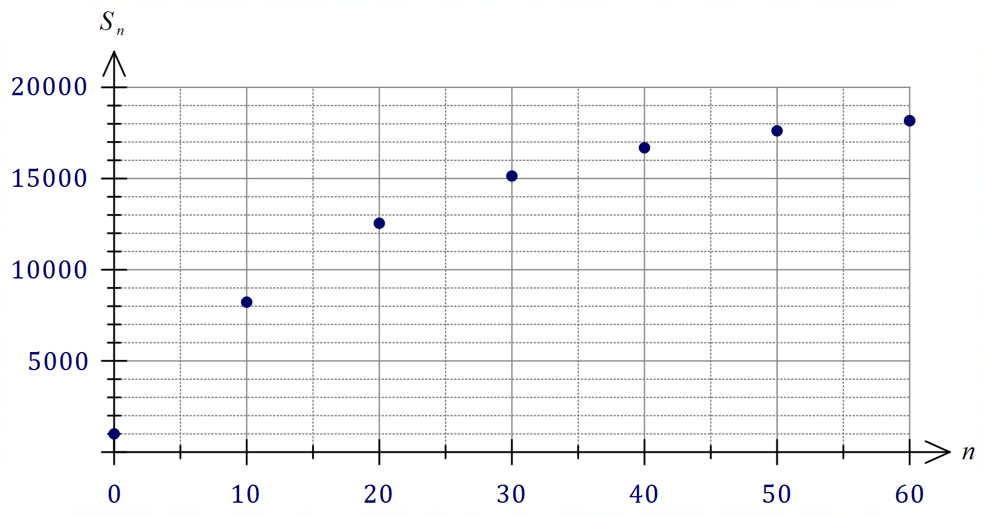

|  |
| --- |
| Solution |
| See graph |
| Specific behaviours |
| ✓ adds scale  ✓ at least 4 points  ✓ all points |

(d) Describe the feature of the plotted points that indicates the salt concentration will eventually reach a steady-state. (1 mark)

|  |
| --- |
| Solution |
| Describes 'levelling off' or 'increasing at a decreasing rate', etc. |
| Specific behaviours |
| ✓ reasonable description |

(e) Determine, with justification, the steady-state salt concentration. (2 marks)

|  |
| --- |
| Solution |
| $$S=0.95S+950⇒S=19 000 \text{ppm}$$ |
| Specific behaviours |
| ✓ equation, or explanation using term(s) with large $n$ ✓ correct concentration |